**Data Analytics Project Report: Sales Data Analysis**

**Executive Summary**

The Sales Data Analysis project aimed to analyze the sales data of a fictional e-commerce company. By leveraging Python for data manipulation, analysis, and visualization, along with MySQL for data storage and retrieval, we explored various aspects of customer behaviour, product performance, and sales trends. This report presents our findings, insights, and recommendations derived from the analysis.

**Table of Contents**

Introduction

Data Exploration

Data Cleaning

Descriptive Statistics

Customer Analysis

Product Analysis

Time-based Analysis

Category-wise Analysis

Data Visualization

Conclusion

Recommendations

**1. Introduction**

The objective of this project was to gain actionable insights from the sales data to aid in strategic decision-making and improve business performance. The dataset comprised information about customers, products, and sales transactions. By conducting thorough analysis and visualization, we aimed to identify patterns, trends, and opportunities within the data.

**2. Data Exploration**

Explored the structure of the database, including tables and relationships.

Checked for missing values and examined the distribution of data.

Identified key variables for analysis and their data types.

**3. Data Cleaning**

Handled missing values through imputation or removal strategies.

Addressed duplicates to ensure data integrity.

Ensured data types were appropriate for analysis by converting where necessary.

**4. Descriptive Statistics**

Calculated total revenue, average order value, and other relevant metrics.

category wise average price: category

Apparel 153.127333

Electronics 150.929333

total revenue: 41085

avergae order: 13.833333333333334

average price: 522.6951219512196

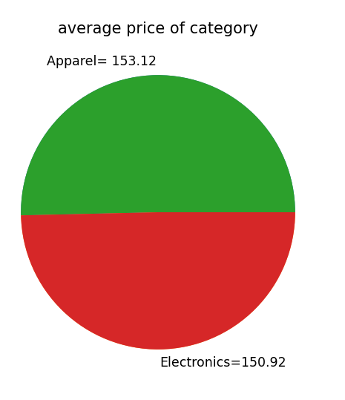

**5. Customer Analysis**

Customers analysis based on sum of sales

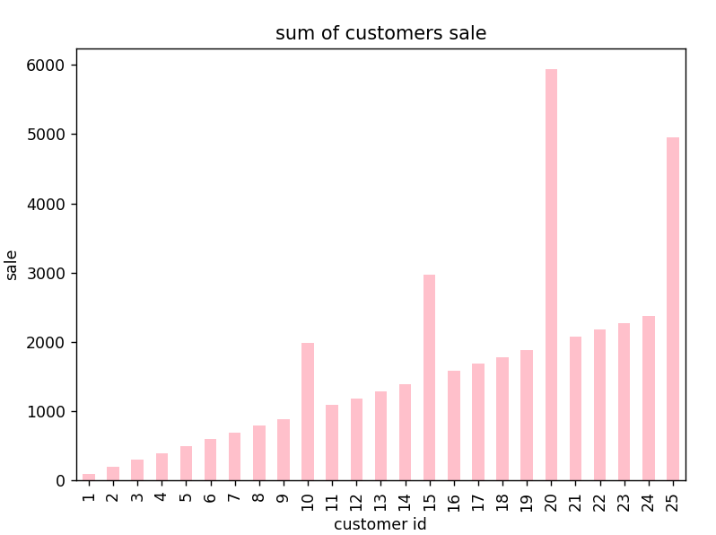

**Top 5 customer id based on spending**

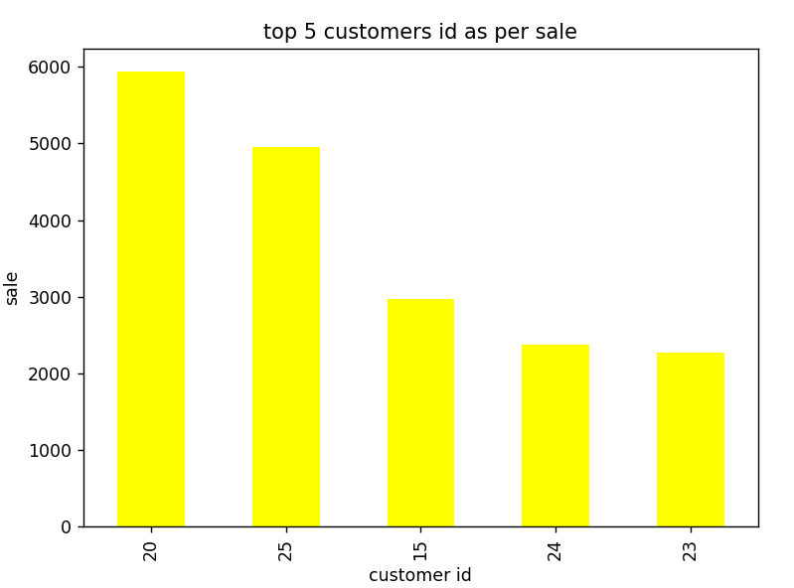

**6. Product Analysis**

Analyzed product sales trends to identify high-performing product id.

Identified top products based on total sales

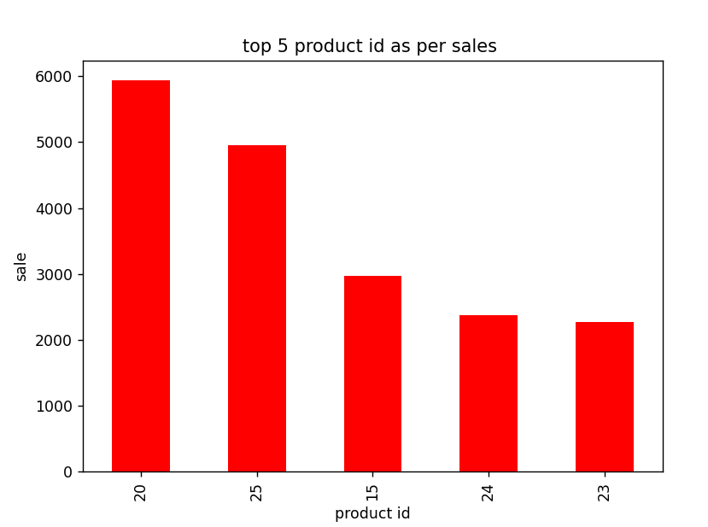

Identified top product based on quantity

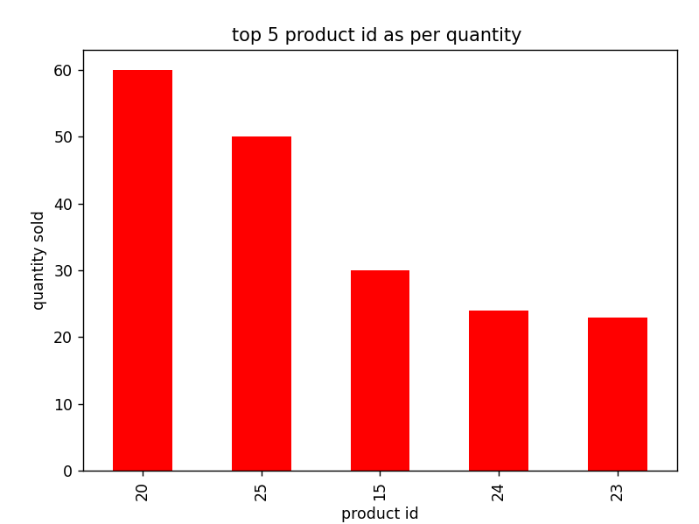

**Analzyzed product sale trend to identify low-performing product id.**

**Identified least product based on sales and quantity**

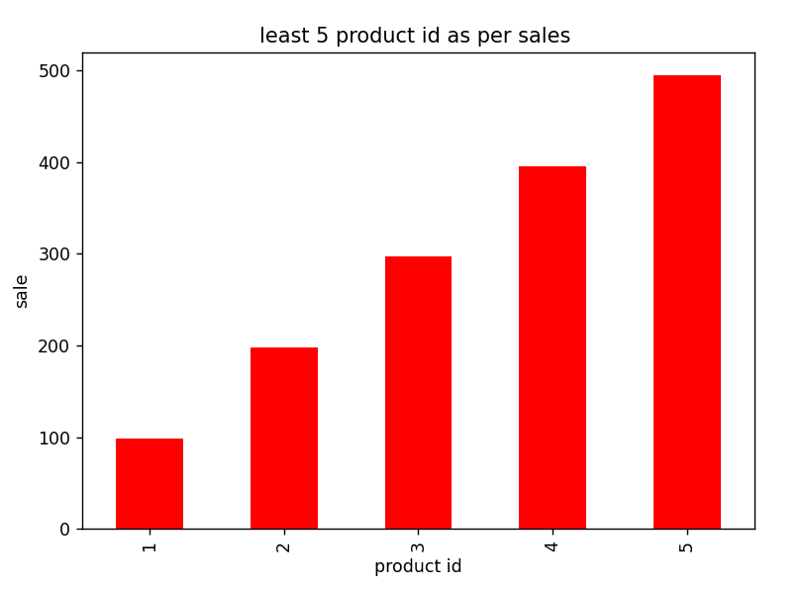

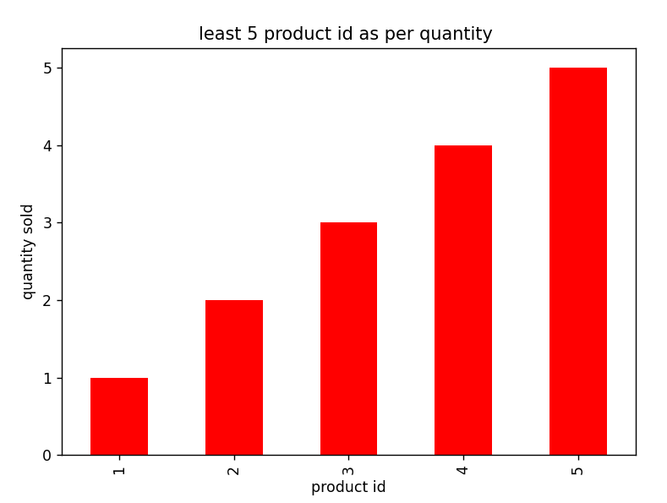

**7. Time-based Analysis**

Analyzed sales trends over different time periods (monthly, quarterly, yearly).

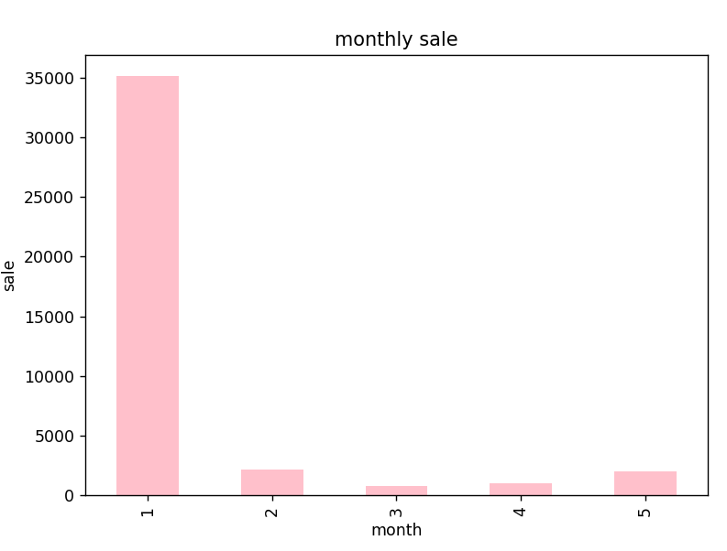

**8. Category-wise Analysis**

Analyzed sales performance by product category to understand category-wise trends and preferences.

Sum of sales category wise

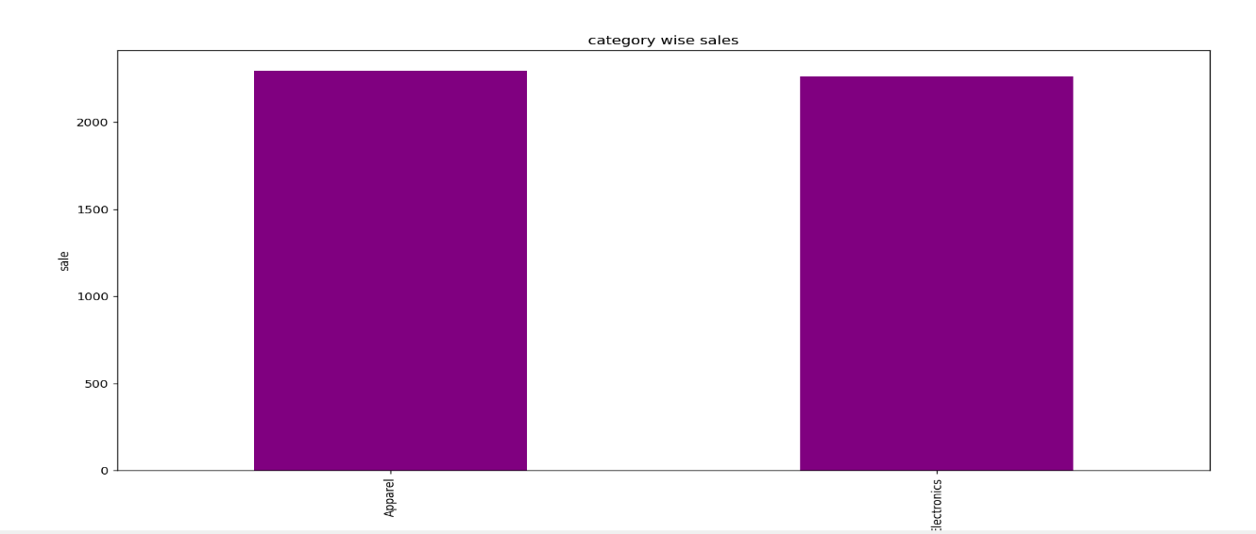

sum of category quantity wise

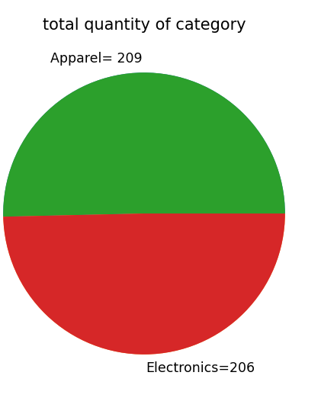

**9. Data Visualization**

Created visualizations using Matplotlib, Seaborn, etc., to represent key findings.

Utilized bar charts, line charts, and other visualizations to enhance understanding.

**10. Conclusion**

In conclusion, the analysis revealed valuable insights into customer behavior, product performance, and sales trends. By understanding these patterns, the e-commerce company can make informed decisions to optimize marketing strategies, inventory management, and overall business operations.

**11. Recommendations**

Based on the findings, we recommend the following:

Implement targeted marketing campaigns to engage top customers and drive sales.

Optimize product offerings by focusing on high-performing categories and discontinuing low-performing ones.

Adjust inventory levels based on seasonal trends and peak sales periods to minimize stockouts and overstock situations.